## Migracion.2d. datos SIRI

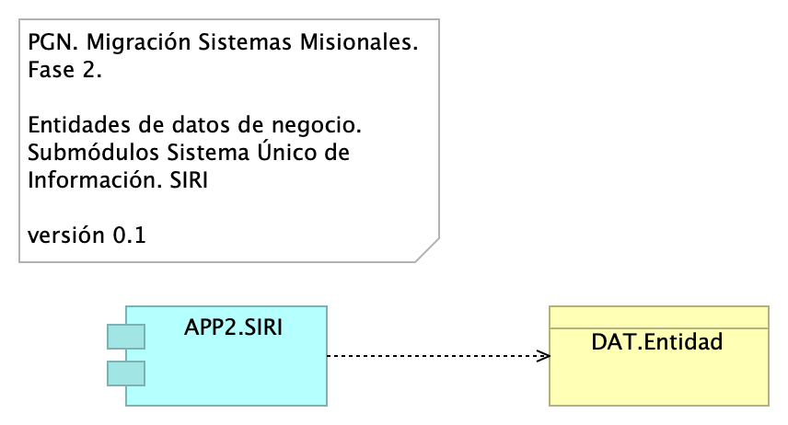

Figure 1: Diagram: Migracion.2d. datos SIRI

### Catálogo de Elementos

| Name | Type | Description | Properties |
| --- | --- | --- | --- |
| **APP2.SIRI** | application-component |  |  |
| **DAT.Entidad** | business-object |  |  |